

**GS-DARK88**

**DANTE NETWORK AUDIO 8 INPUT 8 OUTPUT LINE LEVEL ANALOGUE INTERFACE**

**PRODUCT DETAILS**

##### 6 BROOKS PLACE, MAIDSTONE, KENT, ME14 1HE. ENGLAND. TEL: +44 (0) 1622 753662

**Visit our Website at www.glensound.co.uk FAX: +44 (0) 1622 762330**

 Glensound Electronics Ltd

Thank you for choosing a new Glensound product.

All rights reserved.

Information contained in this manual is subject to change without notice, if in doubt please contact us for the latest product information.

If you need any help with the product then we can be contacted at:

Glensound Electronics Ltd  
1 – 6 Brooks Place  
Maidstone  
Kent  
ME14 1HE  
United Kingdom

Telephone: +44 (0) 1622 753662

Fax: +44 (0) 1622 762330

EMAIL ADDRESSES

General enquires: office@glensound.co.uk

Technical enquires: techinfo@glensound.co.uk

Sales enquires: sales@glensound.co.uk

# PRODUCT WARRANTY:

All equipment is fully tested before dispatch and carefully designed to provide you with trouble free use for many years.

We have a policy of supporting products for as long as possible and guarantee to be able to support your product for a minimum of 10 years.

For a period of one year after the goods have been despatched the Company will guarantee the goods against any defect developing after proper use providing such defects arise solely from faulty materials or workmanship and that the Customer shall return the goods to the Company’s works or their local dealer.

All non-wear parts are guaranteed for 2 years after despatch and any defect developing after proper use from faulty materials or workmanship will be repaired under this warranty providing the Customer returns the goods to the Company's works or their local dealer.

**CE**

This equipment manufactured by Glensound Electronics Ltd of Brooks Place Maidstone Kent ME14 1HE is CE marked and conforms to:

Low Voltage Directive: EN60065

Emissions: EN55103.1

Immunity: EN55103.2

**WASTE ELECTRICAL AND ELECTRONIC EQUIPMENT REGULATIONS 2006 (WEEE)**

Glensound Electronics Ltd is registered for business to business sales of WEEE in the UK our registration number is:

WEE/JJ0074UR

**RoHS DIRECTIVE**

EC directive 2002/95/EC restricts the use of the hazardous substances listed below in electrical and electronic equipment.

This product conforms to the above directive and for this purposes, the maximum concentration values of the restricted substances by weight in homogenous materials are:

|  |  |
| --- | --- |
| Lead | 0.1% |
| Mercury | 0.1% |
| Hexavalent Chromium | 0.1% |
| Polybrominated Biphenyls | 0.1% |
| Polybrominated Diphenyl Ethers | 0.1% |
| Cadmium | 0.01% |

**GLENSOUND DARK88**

**Handbook Contents**

Issue 1

Description Page No.

Contents

PRODUCT WARRANTY: 3

OVERVIEW 6

SIMPLIFIED BLOCK DIAGRAM 7

CONNECTING THE DARK88 TO A DANTE NETWORK 8

Getting Dante Controller 8

Connecting Dark88s To The Network 8

Audio Over IP Network 8

Running Dante Controller 9

Dante Controller TIP 9

UPDATING FIRMWARE 10

WIRING INFORMATION 11

# OVERVIEW

The Glensound DARK88 is an analogue to digital and digital to analogue converter designed to connect line level analogue audio circuits to a Dante audio network.

Dante network audio is a common protocol for distributing high quality linear audio over standard IP networks and it is widely used by many audio equipment manufacturers. The Glensound Dark88 Dante audio interface will be compatible with any other manufacturers Dante audio interface. Further details of Dante network audio can be found at [www.audinate.com](http://www.audinate.com)

Being designed for live on-air broadcast applications the Glensound Dark88 has been designed with multiple redundancy capabilities. It has 2 mains power sources and it also has fully redundant network connections for both Copper & Fibre circuits.

The Dark88 provides 8 analogue line level (0dB) inputs to the Dante network and 8 analogue line level (0dB) outputs from the Dante network on rear panel electronically balanced XLR connectors.

# SIMPLIFIED BLOCK DIAGRAM



# CONNECTING THE DARK88 TO A DANTE NETWORK

The Dark88 is a network audio device utilizing the reliable and versatile Dante audio over IP protocol. Dante is a proprietary system (although very widely used) the originators of which are Audinate.

The information below is only meant as a very basic guide. Full details of the power of Dante network audio and instructions for using it can be found at [www.audinate.com](http://www.audinate.com)

## Getting Dante Controller

If you are connecting the inferno to a new Dante network the first thing you will need to do is to get the free Dante controller software from Audinate.

This can be downloaded by visiting Audinate’s web site at [www.audinate.com](http://www.audinate.com)

## Connecting Dark88s To The Network

Dark88s can be connected to the network that you are going to use for your audio distribution simply by plugging in either, and, or any of the network connections on the rear. Once connected to the network it will be possible to see the inferno from within the Dante controller and route its’ audio circuits.

## Audio Over IP Network

We strongly recommend that you consider your network topology carefully and would not recommend sharing broadcast audio and general data on the same network.

For more details of audio over IP network structure please visit [www.audinate.com](http://www.audinate.com)

## Running Dante Controller

At the time of writing this manual the Dante Controller looks as per the screenshot below:

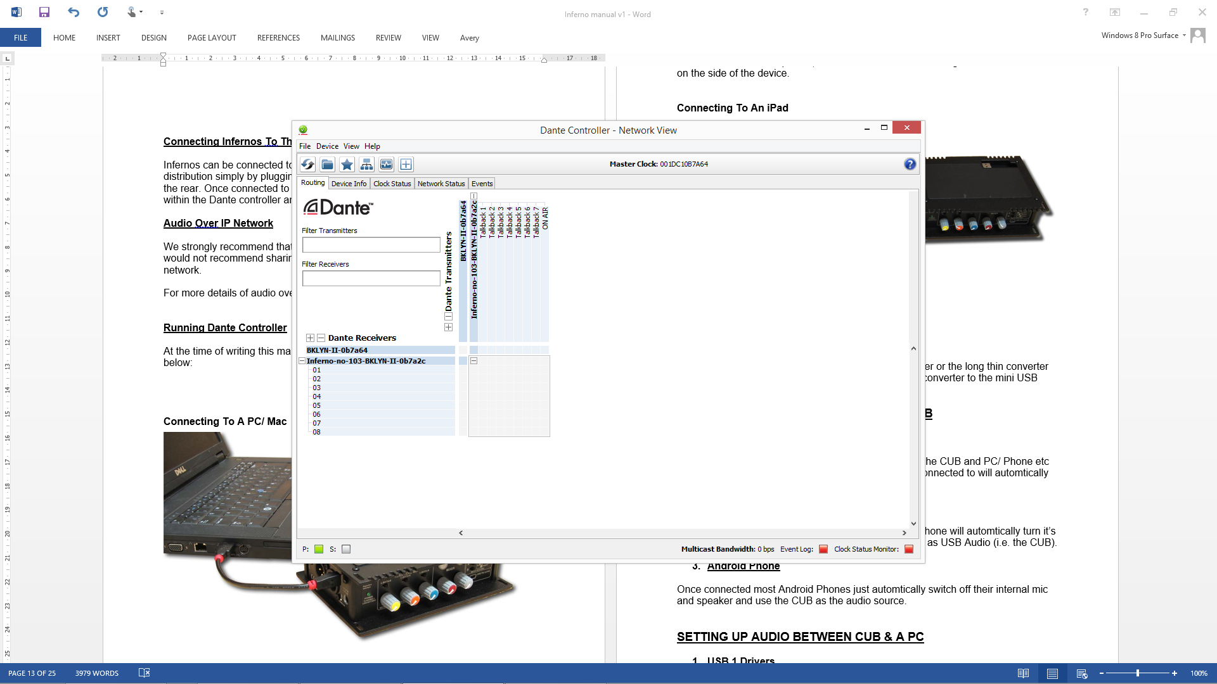

The infernos will have been named at the factory during test to allow them to be identified by the Dante controller.

The format used for the factory name is:

‘Dark88-no-103-BKLYN-II-ob7a2c’

Where ‘Dark88-no-103’ refers to the Glensound product i.e. Dark88 and its serial no (in this case 103) and ‘BKLYN-II-ob7a2c’ refers to the units Dante Brooklyn II module and its MAC address.

## Dante Controller TIP

If you have never run Dante controller before then make sure that on the bottom left of the Dante controllers’ screen ‘P’ or ‘S’ is next to a green square as this indicates that it is connected to a network. By clicking ‘P’ or ‘S’ a pop up box opens to allow you to set what network interface the controller is using.

# UPDATING FIRMWARE

1. **General**

The Dark88 is a complex digital audio system comprising of a DSP and several Micro Controllers. All these items run software and may need to be occasionally updated.

1. **Single File**

One single update file contains all the updated software for the internal devices.

1. **Connect To A PC**

Using the front panel USB connector connect your windows PC to the Inferno. Use Windows Explorer to locate the new software file provided by support and follow supports instructions for loading the new software.

# WIRING INFORMATION



**STANDARD XLR AUDIO PINOUTS:**

**1: Ground/ Earth**

**2: INPHASE/ POSITIVE/ MIC +**

**3: MATE/ NEGATIVE/ MIC -**



**STANDARD HEADPHONE WIRING:**

**TIP: A/ LEFT Ear**

**RING: B/ RIGHT Ear**

**SLEEVE: Common/ Earth**



**Inferno External DC power input:** 2.5mm Barrel, Centre +Ve, 9 to 15 Volts, 1 Amp